

2020

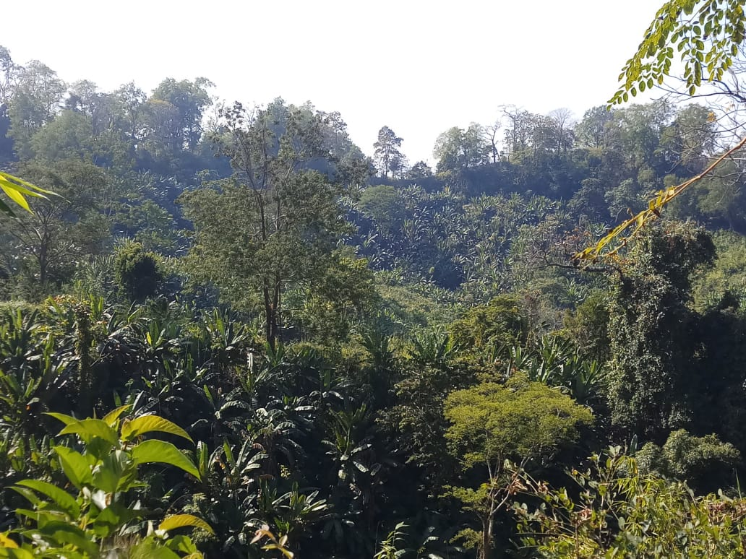

***SCATFORM Manual and Guideline Series No.2***

**Guideline for Eco Development and Microplanning**

**in Gumti Wildlife Sanctuary**





Photograph

**Dr. Alind Rastogi, IFS**

PCCF & HoFF, Tripura

**Date:**

**Message**

I am delighted to note that Tripura JICA Project (SCATFORM) has formulated Guideline on Eco-development and Microplanning for Gumti Wildlife Sanctuary which provides a framework for planning and implementation of the habitat improvement works in Gumti Wildlife Sanctuary with inhabitant of its 27 EDCs. This collaborative effort of Forest Department involving active participation of local inhabitant considering adequate and judicious use of resources, create conservation awareness and incentivizing people’s participation by creating alternative livelihood opportunities will help to protect and restore the natural ecosystems including the faunal and floral diversity.

I appreciate the efforts and contribution of PMU officials and those associated with its formulation and hope this publication will be very useful for the functionaries at PMU and field level in implementing this component of the Project towards the desired outcome.

**(Dr. Alind Rastogi, IFS)**

 Government of Tripura

Forest Department

**Project Management Unit,Tripura JICA Project**

(Project for Sustainable Catchment Forest Management in Tripura)

PrakritiBhawan, Gandhigram, West Tripura 799012

Phone: +91-3812397022, e-mail: [tripurajica@gmail.com](mailto:tripurajica@gmail.com), Website: www.scatfrom.com

Photograph

**Angshuman Dey, IFS**

Chief Executive Officer & Project Director

Dated, Agartala, XX March 2020

**Preface**

Project for Sustainable Catchment Forest Management in Tripura (SCATFORM) has been launched in 2019 with Japanese assistance made available through Govt. of India with the aim of improving quality of forests in the targeted river catchments by sustainable forest management, soil and moisture conservation and livelihood development, there by contributing to development of forest ecosystem services and livelihood improvement of forest dependent communities in the State. Habitat improvement of Gumti Wildlife Sanctuary is an important component of the Project under which eco-development activities will be taken up in 27 identified Eco-development Committees (EDCs) under the control of Wildlife Warden, Gumti Sanctuary.

Guideline for Eco-development and Microplanning in Gumti Wildlife Sanctuary provides a framework for planning and implementation of the activities as per the provisions of Minutes of Discussion (MoD) signed between JICA, Govt. of Tripura and Ministry of Environment, Forest and Climate Change. These Guidelines have been formulated by PMU of the Project in collaboration with PMC Experts and in consultation with the stakeholders. Best practices in Eco-development and field experiences as well as available literature have been consulted in preparation of the Guidelines.

It is expected that these guidelines will provide a handy tool for the field managers in planning their activities effectively to bring about the desired outcome in a time bound manner and with active participation of the stakeholders including the local communities.

(**Angshuman Dey**)

**Guideline for Eco Development and Microplanning**

**in Gumti Wildlife Sanctuary, SCATFORM**

**Table of Contents**

**1.** **Introduction** 4

**2.** **Eco-development strategy in Gumti Wildlife Sanctuary** 6

**3.** **Objective of Eco-development in SCATFORM** 7

**4.** **SCATFORM Approach for Eco-development** 7

**5.** **Eco-development Implementation by SCATFORM in Gumti Wildlife Sanctuary** 7

**6.** **Eco-development planning process** 8

**7.** **Preparation of Micro Plan for Eco-development** 9

**8.** **SCATFORM Project Activities** 10

**9.** **Planning village meetings** 12

**10. Monitoring Framework………………….……………………………13**

1. **Introduction**

National Forest Policy

National Forest Policy of 1988 highlights the active involvement of all fringe population in the management and development of forest resource. In 1990, the Government of India passed a resolution providing specific guidelines regarding the formation, functioning, rights and responsibilities of community forest management groups and launched a centrally sponsored scheme called "Eco-development committees around National Parks and Sanctuaries".

Eco-development is a process to promote conservation through better living condition for local people made jointly by TFD, local communities and other stakeholders.

Eco development strategy

The strategy aims to conserve biodiversity by addressing both the impact of local people in the protected areas and the impact of the protected areas on local people. Ecodevelopment thus has two main thrusts: improvement of PA management and involvement of local people. In doing so it seeks to improve the capacity of PA management to conserve biodiversity effectively, to involve local people in PA planning and protection, to develop incentives for conservation and to support sustainable alternatives to harmful use of resources.

It supports collaboration between the state forest departments and local communities in and around ecologically valuable areas.

It also promotes private-sector stakeholder support for conservation among NGOs, nature tour operators and the common people.

Gumti wildlife sanctuary

Gumti wildlife sanctuary is located in the southern part of Tripura, with an area of 389.5 km2 spread across the districts of Dhalai, Khowai and Gumti. This biodiversity rich semi-evergreen and deciduous forest was notified as sanctuary on 8 September 1988. The area has a mean annual rainfall of 2,625 mm and June to September forms the season of rain. The highest altitude of the Sanctuary is 319 meters. Gumti River is formed on the periphery of the Sanctuary by the confluence of Raima and Saima rivers originating in the watersheds within the Sanctuary. The Sanctuary is also boarded by Khowai River, Dhumbur Reservoir and Bangladesh boarder on different sides.

Institutional arrangement of Gumti wildlife sanctuary

The Sanctuary is managed by a Wildlife Warden, in the rank of SDFO, who reports to the Dhalai DFO as a larger part of the Sanctuary falls under the Dhalai Forest Division. The Sanctuary is administratively divided into 6 Ranges- the Wildlife Warden directly manages three ranges, namely Gandachara, Raishyabari and Ganganagar, while other three ranges are managed by SDFOs as follows: Mungiakami range under SDFO Teliamura, Amarpur range under SDFO Amarpur and Tirthamukh under SDFO Karbook. The Wildlife Warden does the overall coordination. The Sanctuary has a Management Plan for the period 2013-23.

Flora and fauna of the sanctuary

The Sanctuary covers semi-evergreen forests, mixed deciduous forests, savannah woodlands, bamboo brakes, a vast system of wetlands and bils- a system of marshy grasslands. The flora includes species such as *Albizia procera*, *Macaranga sp*, *Terminalia chebula*, *Syzygium cumini*, *Schema wallichii*, *Terminalia belerica*, *Phyllanthus emblica* etc. The sanctuary has six primate species; these and other mammals are listed in Table 1. Elephant though known to be present was not reported in the 2017 Elephant Census.

Table 1: Key mammal species of Gumti wildlife sanctuary

|  |  |
| --- | --- |
| Common name | Scientific name |
| Hoolock gibbon  Slow loris  Capped langur  Phayre’s leaf monkey  Stump-tailed macaque  Pig-tailed macaque  Elephant  Leopard  Jungle cat  Barking deer  Leopard cat  Wild boar | Hylobates hoolock  Nycticebus coucang  Presbytis pileatus  Presbytis phayrei  Macaca arctoides  Macaca nemestrina  Elephas maximus  Panthera pardus  Felis chaus  Muntiacus muntjak  Felis bengalensis  Sus scrofa |

**Source**: Gumti Wildlife Sanctuary, Management Plan.

The Sanctuary is noted for its avifauna and Birdlife International has recognized it as an Important Bird Area and the bird species found here include the vulnerable species the Lesser adjutant stork, and winter migrants such as Lesser Whistling Teal, Garganey, Gadwall, Northern Pintail, etc.

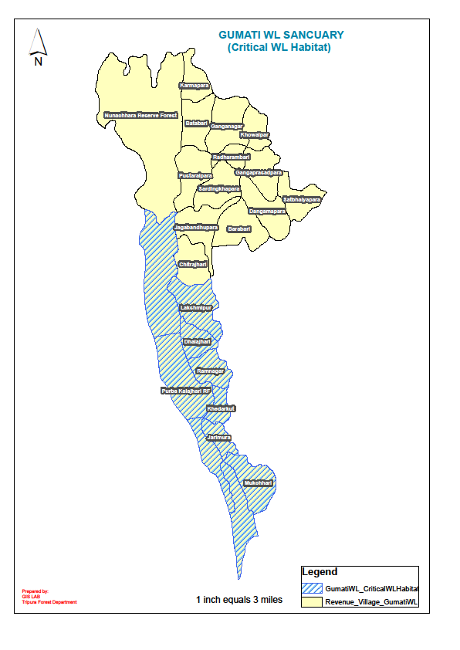

Zoning of Gumti wildlife sanctuary

Gumti wildlife sanctuary is ecologically divided into two parts: Critical Wildlife Habitat (CWH) (6 moujas and one RF) and outside of CWH (12 moujas and one RF).

1. **Eco-development strategy in Gumti Wildlife Sanctuary**

Management plan of Gumti wildlife sanctuary

Management plan of Gumti wildlife sanctuary specifically proposed the following actions for eco development.

1. Settlement of forest rights
2. Livelihood support and resettling of tribes
3. Mitigate human wildlife conflicts
4. Promote best practices incentives/rewards to best forming EDC

Eco development in the sanctuary

Ecodevelopment was practiced in the sanctuary, but currently not active due to the paucity of funds. There are 27 EDCs in the territory of Wildlife Warden of the Sanctuary (inside and outside of the sanctuary). The population in the sanctuary was 4700 households accor0ding to the census in 2001; however, the village where SCATFORM team visited there is approximately six times more population than the 2001 census, suggesting some parts of the sanctuary is heavily colonized. The most of the inhabitants in the sanctuary are tribal population having forest and community rights to use the lands. The Sanctuary has heavy weed infestation, the predominant weeds are: lantana, mikenia, eupatorium and mimosa. There are a large number of cattles in the Sanctuary. The infrastructure facilities for the Sanctuary management are very limited. This Sanctuary was not covered by the TFIPAP.

1. **Objective of Eco-development in SCATFORM**

The objectives of the eco-development activities in SCATFORM are: -

1. To improve socio-economic conditions of villages in and around the sanctuary through actions to settle in Recognition of Forest Rights (ROFR) land, having integration with activities by other projects, Government departments and NGOs.
2. To promote conservation awareness values for long term sustainable utilization of natural resources by reducing anthropogenic pressure on the Sanctuary.
3. To generate alternative employment opportunity forming SHGs to reduce traditional dependency on forests and provision of training and revolving funds.
4. **SCATFORM Approach for Eco-development**

In order to address the defined objective, SCATFORM uses the following approaches in project activities.

1. Provide Entry Point Activities (e.g. Multi utility Centre or others) to EDC.
2. Organize EDC to specify the area of RoFR lands provided to each landholder as a basis of sustainable land-based production activities.
3. Make EDC members to participate in sustainable agro forestry production including fruit cultivation, grassland development, weed eradication, fire line making, check dam construction, gully plugging, boundary marking, etc.
4. Promote Income generation activities by forming SHGs (or with existing SHGs) with the provision of revolving fund.
5. Promote environmental education through school activities.
6. Facilitate EDC to participate in Rural development programs[1].
7. **Eco-development Implementation by SCATFORM in Gumti Wildlife Sanctuary**

SCATFORM in Gumti Wildlife Sanctuary will be implemented through the existing 27 EDCs in 13 beats, three ranges in the territory of Wildlife Warden of the Sanctuary. Tentative list of EDC/JFC based on the name of original formations are shown in Table 2.

**Table 2: Tentative EDCs and JFMCs lists undertaken in SCATFORM**

|  |  |  |  |  |
| --- | --- | --- | --- | --- |
| Name of Range | Name of Beat | Name of Village | Sl. No. | Name of JFMC/EDC |
| Gandachara | Jagabandhu Para | Jagabandhupara | 1 | Dalirai Para EDC |
| 2 | Balong humkarai EDC |
| Gandachara Proper | Laxmipur | 3 | Laxmipur EDC |
| Gandachara | 4 | North Sarma |
| Pancharatan | 5 | Matima Chakma |
| Laxmipur | 6 | Machkumbhir |
| Ultachara | 7 | Khakchang |
| Dhalajari | Ramnagar | 8 | Ramnagar EDC |
| 9 | Sangrangma EDC |
| Ranipukur | Sarma | 10 | Jarikusum |
| Pancharatan | 11 | Ranipukur |
| Hatimatha | Dalapati | 12 | Hatimatha |
| Dalapati | 13 | Dalapati |
| Bhagirath Para | Bhagirath Para | 14 | Mohinya para |
| 15 | Dhanuram Para |
| 16 | Naba Kumar Para |
| Raishyabari | Raishyabari Proper | Bowalkhali | 17 | Bowalkhali |
| Tuichakma | Thakurchara | 18 | Thakurchara |
| Tuichakma | 19 | Chandidas Para |
| Raima | Raima | 20 | Indrakishore |
| 21 | Khetradhan Roajapara |
| Potachara | Purba Potachara | 22 | Purba Potachara |
| Paschim Potachara | 23 | Paschim Potachara |
| Ganganagar | Ganganagar Proper | Ganganagar | 24 | Ganganagar EDC |
| 25 | Naithok EDC |
| Karmapara | Karmapara | 26 | Salpaha EDC |
| Karnamoni Para | Karnamoni Para | 27 | Sisathai EDC |

1. **Eco-development planning process**

SCATFORM plans to carry out the following procedures in its planning process.

1. Review management plan and other existing materials.
2. Socio-economic and Resource Survey.
3. Identification of Impact Zone.
4. Prioritization and Selection of target villages.
5. Agreement with the village for reconstitution or new formation of EDC/JFMC.
6. Preliminary analysis for Micro plan.
7. Conduct Participatory Rural Appraisal with local community and discuss about the Preliminary Plan.
8. Preparation of Eco-development Micro plans.
9. Submission and Approval of Micro plans.
10. **Preparation of Micro Plan for Eco-development**
11. **Collect general information of the village from available document**

* Village socio economic profile (demography, education, land holdings, livestock, RoFR, scheme conducted/operational, etc.).
* Understanding existing organizations and micro plan. EDC formed before, General body, executive committee, other existing organizations.

1. **Participatory Rural Appraisal (village meetings with key informants)**

* Village Transect Map: will give a bird’s eye view of topography of village, Helps understanding special distribution of different types of natural resources and also help in building initial rapport with villagers.
* Historical Timeline: Helps in understanding change in resource use pattern by the villagers with the time. It also helps in understanding prevailing condition/ status of resource.
* Village Social Map: It helps in gathering data related to Socio economic profile of that village along with demographical features.
* Village Resource Map: Helps in understanding special distribution of Natural resource, their condition/status and Strength (stock), Weakness (causes of degradation) and Opportunity (possible scope) to improve the same.
* Seasonal Calendar:  Helps to understand seasonal occupancy and lean period.
* Venn Diagram: Helps in understanding Institution/s near or inside villages and dependency of villagers on the them.
* Participatory Wealth Ranking: Helps in understanding different economical strata prevailing in the village and Identifying Poorest of the Poor families.

1. **Making a plan in timeline**

Making a five year' plan and the first year plan for proposed activities.

1. **SCATFORM Project Activities**

The following project activities can be planned in Gumti wildlife sanctuary. It should be noted that EDC (inside sanctuary) and JFMC (outside sanctuary) are different schemes.

Entry point activities: Multi utility centre or similar infrastructure can be constructed.

Forest management (Only JFMC)

Size of target area for each plantation scheme in the selected beat will be calculated by the average of project target area for each scheme (Table 3).

Table 3: Average size of plantation activities per beat

|  |  |  |  |
| --- | --- | --- | --- |
| Plantation scheme | Project target area | Average size per JFMC (ha) | Project period |
| Afforestation (AR) | Reserve forest | 12 | 5 years |
| Assisted Natural Regeneration (ANR) | Reserve forest | 50 | 5 years |
| Silvipastoral plantation | Reserve forest | 2.4 | 4 years |
| Filter stripe/riverbank plantation | Reserve forest | 740m per beat | 4 years |

Habitat Improvement

Following activities will be undertaken for livelihood development and sanctuary management in the wildlife sanctuary (Table 4).

Table 4: Activities and size of habitat improvement and livelihood activities

|  |  |  |
| --- | --- | --- |
| Activity | Project target area | Size (ha, number) |
| Fruit tree planting | Inside sanctuary | 600 |
| Grass land development | Inside sanctuary | 375 |
| Eradication of invasive weeds | Inside sanctuary | 330 |
| Check dam- earthen  Average size: 16m L x 16.5m W x 3m H | Inside sanctuary | 12 |
| Gully plugs. | Inside sanctuary | 40 |
| Installation of check post and guard’s room.  Check post: 10 m L, 1.3 m H  Area of guard’s room: 225 square feet | Inside sanctuary | 2 |
| Fire line making.  Breadth: 5 meters | Inside sanctuary | 40km |
| Boundary marking with pillars.  Pillar size: 1.3m x 0.5m x 0.5m | Inside sanctuary | 500 |

Soil & Moisture Conservation (EDC and JFMC)

Number of soil and moisture conservation measures for each JFMC is summarized in Table 5.

Table 5: Number of soil and moisture conservation measures for each JFMC

|  |  |  |
| --- | --- | --- |
| Item | Purpose | Quantity/JFMC |
| Check dam | Water conservation, domestic water use, fishery and irrigation | Model1: 3 dams  Model 2: 2 dams  Model 3: 0.2 dams |
| Brushwood check dam | Erosion protection in gullies | 3 dams on average |
| Contour trench | Erosion protection on hillsides | 2 ha per Model 1 and brushwood check dam |
| Mulching and plantation around the SMC structures | Erosion protection around SMC structures | 2 ha per check dam and brushwood check dam |

Livelihood development (EDC and JFMC)

Livelihood development support are summarized in Table 6.

Table 6: Livelihood development for each JFMC/EDC

|  |  |  |
| --- | --- | --- |
| Project scheme | Average amount per JFMC/EDC | Project period |
| Agroforestry development | Appr. 20 ha  On certified ROFR land | 5 years |
| SHG formation | 3 SHG in total | 5 years |
| Revolving fund | 100,000 INR per SHG | Through several installments |
| Capacity development | Various items  Planed as required | 5 years |
| Cluster formation | As planned and agreed | Decided at later stage |

1. **Planning village meetings**

SCATFORM plans three village meetings for formulation of a micro plan. Typical meetings with villagers will be carried out by the following agenda.

Village meeting agenda

|  |  |  |
| --- | --- | --- |
| Item | | Contents |
| First meeting: | | |
| Objective | 1) introduction of the SCATFORM to villagers, 2) understanding of existing interaction between sanctuary and village, 3) Forest mapping with villagers to identify zones used by villagers with landmarks and 3) making agreement to form/reform EDC. | |
| Participants | RO BO, LC/CO, Village leader and Villagers. | |
| Length | Approx. 3-4 hours. | |
| Second meeting: | | |
| Objective | Participatory Rural Appraisal: 1) Village Transect Map, 2) Historical Timeline, 3) Village Social Map, 4) Village Resource Map, 5) Seasonal Calendar, 6) Venn Diagram and 7) Participatory Wealth Ranking | |
| Participants | RO BO, LC/CO, Village leader and Villagers. | |
| Length | Approx. 3-4 hours. | |
| Third meeting | | |
| Objective | Making Micro plan   * Village Development Plan (Community Development Plan, Forest Development, AgroForestry, Income Generation Activities, Livelihood Intervention, Human Resources Development/ Capacity Building Plan). * Forest Resource Development plan. * Annual Action Plan. | |
| Participants | RO BO, LC/CO, Village leader and Villagers. | |
| Length | Approx. 3-4 hours. | |

1. **Monitoring Framework**

Activities planned in the microplan can be effectively monitored by the involvement of FD and EDC following Table 7 as mentioned below.

Table 7: Monitoring and Evaluation

|  |  |  |  |  |  |
| --- | --- | --- | --- | --- | --- |
| **Major Indicators** | **Activity** | **Frequency** | **Means of Verification** | **Responsibility** | |
| **FD** | **EDC** |
|  |  |  |  |  |  |
|  |  |  |  |  |  |
|  |  |  |  |  |  |
|  |  |  |  |  |  |
|  |  |  |  |  |  |

Microplan is a dynamic document which may be changed as per requirement. Therefore, each microplan should be revised on 3rd year of project for corrections and modifications. Moreover, progress of each year should also be recorded in the microplan, which would also facilitate monitoring of the project activities under other schemes through convergence.

1. The following activities may be facilitated by SCATFORM with the support of other departments.

   Construction of houses, electrification, construction of community hall, drinking water, SHG support, LPG connection, countermeasures against animal conflicts, Primary health care, road improvement, public library, rural health improvement.